

RaaS „Welcome Call“ – Guide for TAMs



**Dynamics CRM**

Prepared for

TAMs

20-Oct-2015

Version 1.1

Prepared by

Julien Clauzel

Table of content

Objectives of the « Welcome Call » 3

This document will be used at the "Welcome Call" by the PFE & TAM to present the above items as well as use the PowerPoint presentation: "DynamicsCRM-RaaS-Welcome Mtg. Pptx." 3

Initial prerequisites for the TAM 3

RaaS key objectives 3

Global process overview 3

Prerequisites 3

In case of errors while performing data collection 4

Immediately reach out to the PFE 4

How to open an User Voice ticket 5

On the day of RaaS delivery 5

What do we collect? 5

Building blocks RaaS 5

Prerequisites Script (Mandatory) 6

Checks performed 6

Usage 6

Example 6

The Objective from running the scoping tool 9

*Verifying that the user running the script has the SQL Server SYSADMIN role* 10

*Next step* 10

Collect phases using the RaaS client for CRM 11

Best practices 11

If tools machine does not have Internet access 11

« Known issues » 11

Do we have a « good enough » data collection? 12

Deliverables 13

Annexes 13

# Objectives of the « Welcome Call »

The objectives are multiple:

* Make sure all parties understand the overall process
* Roles and responsibilities of every stakeholder
* Tools that are being used
* Expected outcome deliverables
* Plan the key milestones and meetings

The "Welcome Call" must be made ​​one month in advance. The initiator is the TAM. The attendees are:

* Customer
* PFE
* TAM

# This document will be used at the "Welcome Call" by the PFE & TAM to present the above items as well as use the PowerPoint presentation: "DynamicsCRM-RaaS-Welcome Mtg. Pptx."

# Initial prerequisites for the TAM

The TAM checks that the custom can access the: <https://services.premier.microsoft.com/> services portal, that the engagement was correctly provisioned and the RMOT request was sent,

* To access the portal the customer requires a machine with: IE9 + Login (live ID) as well as internet access to the site. The TAM verifies prior the welcome call that these prerequisites are being met.

The TAM reads and takes the time to understand the prerequisites document as well as tests the prerequisites script …

It is important to underline to the customer that a RaaS is per environment. In general RAAS is made on the production platform.

/!\ It is technically possible to execute the RaaS client on preproduction environments for evaluation though the data must not be submitted at the end of the process as once the data is uploaded on the portal it can’t be reset or cleared.

# RaaS key objectives

* Identify what are the « top » 3 potential issues (3 issues). Customer owns the remediation if applicable. There are two key metrics being used in RaaS: **health (now)** and **Risks (issues that may potentially happen in the future if not remediated)**.
* There are three key deliverable (Doc, PPT and Excel) in English only.
* Customer can run the RaaS client at his own pace for a year (starting initial download time) and evaluate how the platform evolves as well as the remediation action impact.

# Global process overview

## Prerequisites

* **Customer** & **TAM** read the prerequisites document.
* Customer deploys the tools machine and implement all the prerequisites.
* **Customer verifies that all the prerequisites are in place as quickly as possible with the prerequisites script**. TAM drives activity very closely with the customer. If any issue occurs TAM supports the customer with making sure all prerequisites are in place. In case of an error TAM opens a UV support ticket, notifies the engineer. **ALL prerequisites must be in place and prerequisites script must returned “PASSED” prior running the RaaS client**. Some “Warning” may be acceptable and a “good enough” data collection may be archived.
* Customer downloads the RaaS client as well with the key from the services portal (note there is a **10 days expiration token time frame** so customer should download within this time frame after engagement has been provisioned).
  + Note: If a previous RaaS client or Offline RaaS client is installed on the tools machine it needs to be uninstalled first and the “Documents” “RaaS” folder of the user running the data collection needs to be renamed to “RaaS_Previous”.
* Customer fills in the online survey: it is common that the customer needs to sub dispatch some questions to several internal team so he needs to start performing this activity as quickly as possible (for example to infrastructure teams, backup teams, dev teams/partner, …).
* Customer performs a first initial test data collection (plan 4h30). The idea here is to make sure that there are no key issues found during data collection and if yes fix them as quickly as possible.
* Once the first test data collection has been performed the customer renames the “Documents” « RaaS » folder in « RaaS_old ». The aim is to have the best data collection as possible and possibly get rid of all previous errors he might have had due to missing prerequisites.
* Customer runs the second data collection at peak load the next day and submits the data.
* **Once the data has been submitted he notifies the TAM and PFE**, if any issue happens he needs to notify the TAM and PFE as quickly as possible. **TAM plays a key role to make sure that the data is submitted on time with low failure rate due to missing prerequisites at least two weeks prior the day of the analysi**s.
  + TAM connects to the service portal to verify that:
    - Data has been submitted successfully.
    - Survey has been fully filled.
* PFE verifies data & survey are fine (data show up in visualizers on the web portal) and report can be successfully generated. He then confirms to the TAM and customer that everything needed is there or heads up the TAM.
* TAM & PFE plans a 1:1 to discuss key finding and remediation plan prior the conference call in the evening with the customer.
  + TAM « owns » and drives the remediation plan discussion with the customer.
* TAM plans the « closing call » with the customer.
  + Throughout the conference call we will go through the findings and start discussing the remediation plan if needed. This allows to define post services if applicable.
    - TAM drives the RPS discussion throughout the conference call.

## In case of errors while performing data collection

### Immediately reach out to the PFE

TAM updates PFE within a week following “Passed” data collection feedback returned from the prerequisites script. TAM drives the data collection in order to be successful. It is absolutely the key rely on the prerequisites script to make sure that the customer has a good enough data collection to be analyzed.

### How to open a User Voice ticket

[http://PPAS.uservoice.com](http://ppas.uservoice.com/)

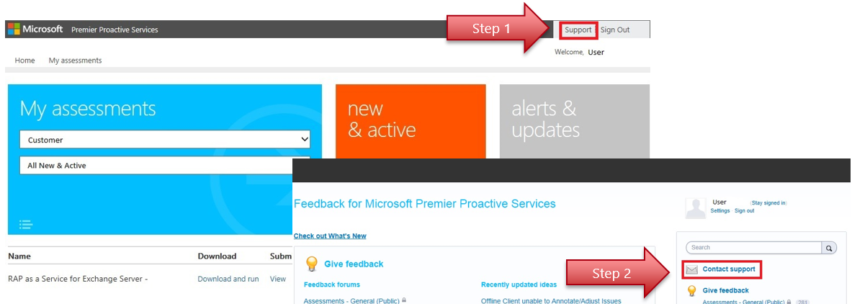

## On the day of RaaS delivery

* Morning: PFE analyzes the data collected and generates the various deliverables (doc, ppt, xls).
* First half of evening: PFE & TAM prepare 1:1 the closing conference call / RPS.
* Second half of evening: PFE + TAM + Client « Closing Conf Call ».
* Closing of engagement (Axis …).

# What do we collect?

* The following key vital signs of the bellow components are collected:
  + Windows,
  + SQL,
  + IIS,
  + CRM

The data collection is « non-intrusive» as most of it is sequential and based on several years of feedback and experience on CAVE (Collection Analysis & Visualization Engine). We do not change anything.

Impact on production is minimal. For this specific reason we request a tools machine to be used to reduce the impact on the existing CRM workload as much as possible.

Data transfer between RaaS client and the Premier services Portal is encrypted and secured. In the specific case of Offline RaaS no data is transferred to Microsoft.

## Building blocks RaaS

The Dynamics CRM RaaS relies on the following standard « Building Block »:

* Windows,
* SQL,
* IIS (this is currently a different version from the “IIS RaaS”, with specific Dynamics relevant rules).
* Our own CRM building block. Some of its rules rely on the data collection of the three above collectors.

The RaaS « discovery » service code is specific to CRM and discovers the following roles: Windows, SQL and CRM.

Note: **The Email router is not discovered** and we have no specific rule currently targeting it. If you know that there are specific issues related faced by your customer on this component, **let us know prior starting the analysis**.

# Prerequisites Script (Mandatory)

## Checks performed

The scoping tool, is a VBS script that verifies your tools machine to check if it is ready for collecting the data, and all needed prerequisites are in place for using RaaS Client tool.

The VBS script also uses a TestPort.ps1 PowerShell script that is executed as part of the analysis. The TestPort.ps1 script must be deployed in the same directory as the VBS script.

Script is divided into three phases:

* Phase 1 and 2 - Verification of prerequisites on the machine tool itself.
* Phase 3 - Check that the machine tool can: connect to different servers, checking privileges, the IIS logs are active, etc ...

At the end of each phase and at the end of the script the number of errors are summarized.   
Two log files are generated (CRMRaasPreReqsFailuresLog.txt and CRMRaasPreReqsScriptLog.txt) located in the same directory where the tool is located, and can be shared with the TAM or PFE if needed.

## Usage

From a command line, with privileged permission execute the (run as administrators) script as follows:

|  |  |
| --- | --- |
| Scenario | Command line |
| For a simple deployment where everything is consolidated on a single server. | Cscript VerifyCRMRaaSPreReq-V3.3.vbs frontcrmserveur |
| More complex deployments over more than one server, list the name of each server (separated by a space) as the tool can’t discover it by itself, | Cscript VerifyCRMRaaSPreReq-V3.3.vbs frontcrmserveur1 frontcrmserveur2 serveursql1 serveursql2 |

## Example

Output is divided in 4 sections:

1 - Performing tool machine local tests.

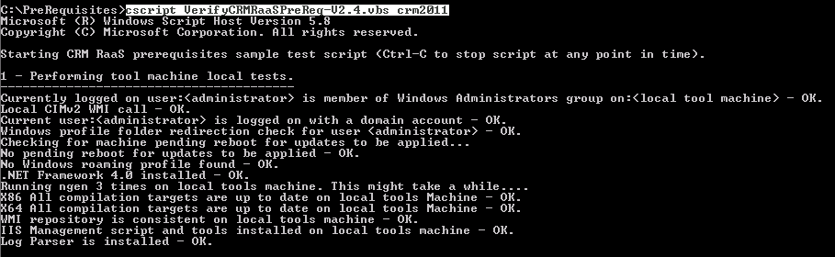

2 - Analyzing tool machine configuration.

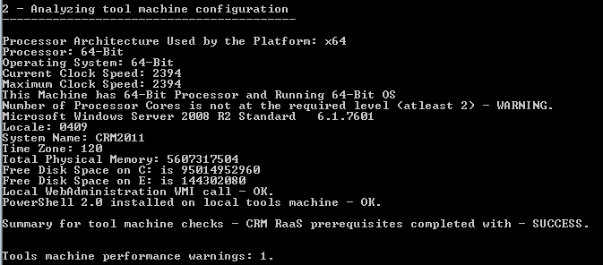

3 - Performing remote tests on CRM Servers and including SQL sysadmin role check

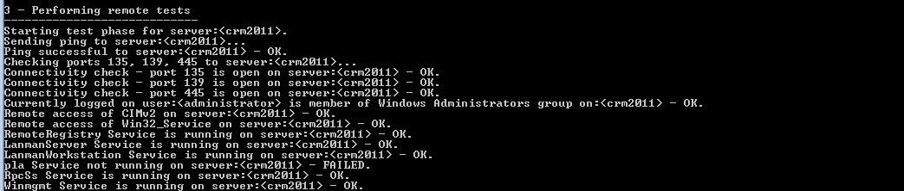

3 - Performing remote tests on CRM Servers and including SQL sysadmin role check – **user Input is required**

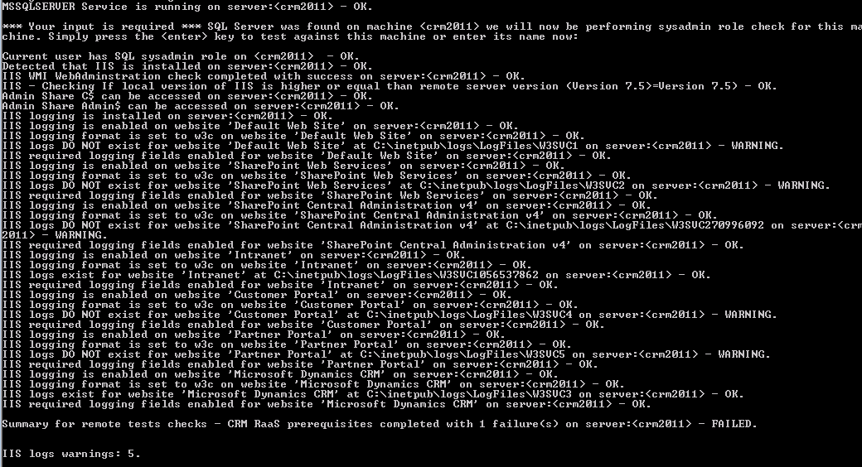

4 – Overall summary results (With Error)

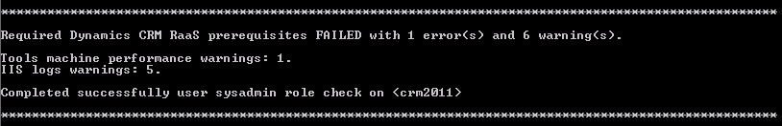

If look in greater details we had:

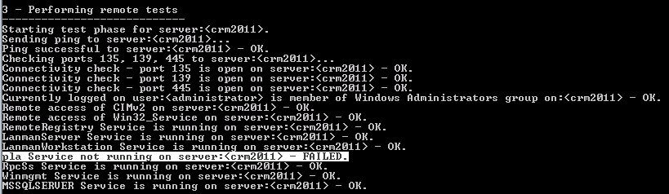

Always attempt solving all errors until “PASSED” is displayed in the overall summary results section.

Here we start the pla service from an elevated cmd shell.



4 – Overall summary results. (With No Errors)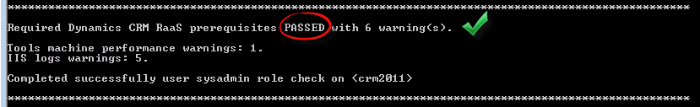

By default, the script will detect when a server has SQL Server installed and started, then will ask for user input to verify that the user has sysadmin rights on SQL Server.

"*** Your input is required *** SQL Server was found on machine <crmfrontcontoso> we will now be performing sysadmin role check for this machine”.

In a simple non-clustered configuration it is usually sufficient to press “Enter” at the question.

When SQL Server is deployed on a different machine please enter machine name.

In more complex scenarios where SQL Server is deployed on a different Machine, please enter the SQL Server instance name.

If you don’t know the SQL Server machine/instance name, please check with your DBA.

**It is absolutely necessary to successfully complete the prerequisite test.** This is often problematic in complex organizations as DBA’s have not given this privilege to administrators CRM. It is therefore necessary to perform this test as soon as possible in case of need to request a temporary waiver from SQL teams.

# The Objective from running the scoping tool

The ideal solution is to get to the end of the script execution with the following result:   
Required Prerequisites Dynamics CRM RaaS PASSED with 0 warning (s).

Although "Passes with Warning", is ideal it does mean that we have a collected sufficient data. It is therefore necessary to work with the prerequisites to obtain at least "Required Prerequisites Dynamics CRM Rap as a Service" PASSED ". Verifying that the user performing the collection has sysAdmin rights on the CRM database instance

Once the tool returns no errors and shows a status of “PASSED" the installation of the tool-RaaS can be done and collection of results can start.

|  |  |
| --- | --- |
| **Sample summary output with failures at end of script** | **Sample summary output with failures PASSED at end of script** |
| Required Dynamics CRM RaaS prerequisites **FAILED** with 1 error(s) and 6 warning(s).  Tools machine performance warnings: 1.  IIS logs warnings: 5. | Required Dynamics CRM RaaS prerequisites **PASSED** with 0 warning(s).  **Completed successfully user sysadmin role check on** <crm2011> |

# Verifying that the user running the script has the SQL Server SYSADMIN role

The following example shows how to verify that the account CONTOSO \ Administrator does have the sysadmin rights.   
Opened SQL Management Studio -> Open "Security" -> right click "Property" on the target account -> Browse "Server Roles" tab "sysadmin" group must be checked.

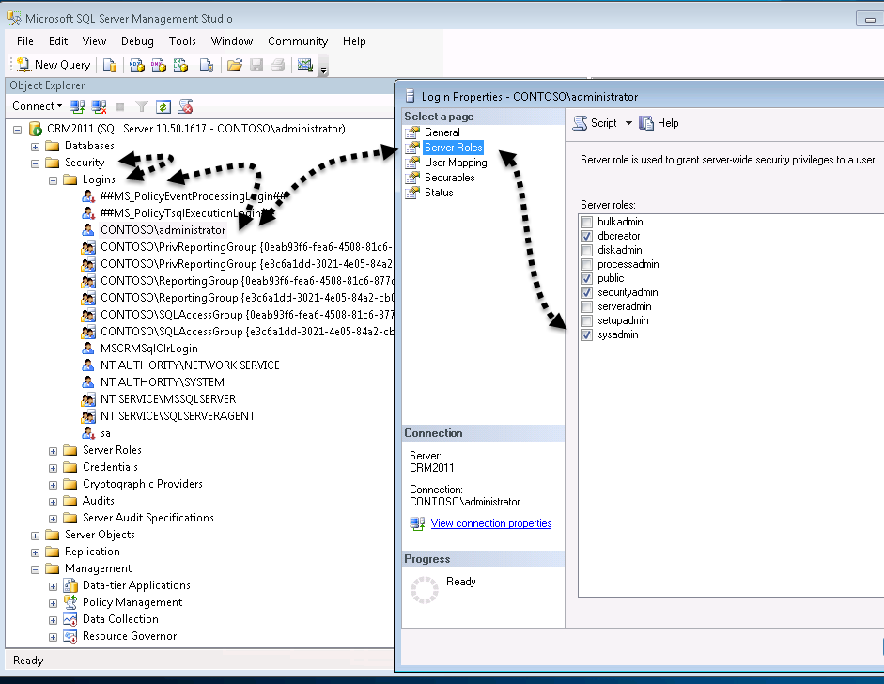

* + If the account does not appear in the list or sysadmin does not appear. It is possible that the account you use to log on does not have sufficient privilege to SQL to see the rights of certain users. -> Contact DBA.
  + If the account appears in the list but does not have the “sysadm” role checked, grant the account “sysadm” rights or contact the DBA to do so.

# Next step

Run the RaaS Client Tool.

# Collect phases using the RaaS client for CRM

RaaS Client install is simple (MSI simple, « next, next »), the RaaS client only verifies some basic prerequisites for the engine itself in this case if: Framework .NET 4.0 is installed.

This does not mean that CRM prerequisites are met this is why using the prerequisites script is so important. The prerequisites script is currently the best method to verify they are met. If there are errors that show up at script execution time let your PFE know and open a UV ticket (note: RaaS support team may be unaware for the specific CRM RaaS script but they should be able to help on making sure prerequisites are met). Also in case of error analyzing prerequisites script log is a first stop. Logs may only be transferred to PFE using secure file transfer (open a secure file transfer if needed). In the log all errors should be easy to spot by searching the: « FAILED » keyword. At the end of the script the total number of errors is displayed.

When the RaaS Client is first started:

* + The user needs to input the name of a CRM application frontend server. This allows the « discovery » of all the servers in the environment related to CRM (SQL, CRM, IIS…). Note: the email router as detailed earlier on in this document is not discovered.
  + The data collection is then performed in two phases : configuration & settings then performance counters

|  |  |
| --- | --- |
| Collection phase | Average time |
| Configuration & settings | 10 minutes |
| Performance counters | 4h |

## Best practices

* Always try to execute the RaaS client when there is expected peak load for example first half of the evening.
* When a first data collection has been performed without any major collector failure due to missing prerequisites, rename the « RaaS » folder in the user “Documents” folder to « RaaS_old » and the next day at same peak load perform an new data collection.

## If tools machine does not have Internet access

At the end of data collection choose the option to package and provide key.

Install the RaaS client on another machine that has internet access and then choose the « upload » option and provide the key.

# « Known issues »

* Some errors may occur while collecting IIS logs and some IIS collectors may fail. (They usually should have triggered some prerequisites tools warning) – Let your PFE know but these errors may not block from delivering and data collection should be “good enough”.
* Log Parser install missing causing IIS collector errors.
* « IIS script and tools » missing causing IIS collector errors.
* Some CRM installation create a specific IIS new site such as CRM Web site and leaves the IIS “Default Web Site” empty. This causes IIS collector errors because there are no logs available for the “Default Web Site”. This can be safely ignored.
* Users with Windows roaming profiles, locally cached profiles, or folder redirection are not supported and cause errors.
* Customers often miss many perquisites, **don’t wait to use the prerequisites script.**
* When error occurs during data collection :
  + Close RaaS Client.
  + Rename the « RaaS » folder in the user “Documents” folder to « RaaS_old »
  + Start a new data collection.
  + *Explanation*: The first time the RaaS client is started and server name is provided the discovery code is triggered. On subsequent starts of the RaaS client the discovery code is skipped if the “Documents” folder to « RaaS » folder is present. If some prerequisites are missing some discovery errors may occur and discovery may not be complete and generate later on data collection errors. The tip is a detailed above, close RaaS client, rename the « RaaS » folder in the user “Documents” folder to « RaaS_old ». Start a new data collection to trigger a new discovery once prerequisites have been fixed.
* The version of the OS (and IIS) on the tools machine must be equal or higher that the targeted CRM Server version (especially for IIS).
* The tools machine **must be domain joined in the same domain of the CRM servers**.
* The user account performing data collection must be a **domain** account.
* The user account used to logon on the tools machine **must not log on locall**y (with a local account). The account used must be a **domain account** (mirrored local accounts with same login passwords are not supported).
* The domain account used to logon on the tools machine **must be part of the local administrator group on all machines including tools machine.** We have some checks for this in prerequisites script though it will not work for languages such as Chinese, Russian, Hebrew, Greek as this was too complex to implement short term.
* Some firewalls or customizations performed to Windows Firewall may block RPC/SMB, having WMI working properly between RaaS clients and each server is a “must have”. The prerequisites script extensively test/ rely on that, use it as soon as possible in the delivery process.
* Internet access is required to submit data from RaaS client to the premier service portal. If the RaaS client can’t access directly the internet you’ll need to deploy a temporary client that has access though again the internet access may go through blocking proxies that provide limited access by applying all sorts of filtering.
* If a previous RaaS client is already installed on the tools machine, uninstall it first. Don’t try to reuse it. Rename the previously generated « RaaS » folder in the user “Documents” folder to « RaaS_previous ».
  + Download on regular basis new RaaS client from premier services portal. The RaaS client does not self “Windows Update” you need to download the latest bits to get the set of rules/checks (if they have been updated in the meanwhile).   
    Note: Offline RaaS client rules are never updated. Once the RaaS Offline client has been downloaded the same rules & checks are preserved for the full year.

# Do we have a « good enough » data collection?

Having a « good enough » data collection doesn’t mean we have no failing collectors. It means we have enough significant data to detect the possible top 3 issues that needs to be addressed first.

/!\ TAM and **customer** are the drivers of the data collection for this reason it is important to make sure all prerequisites are in place as early as possible in the process and to make sure that the prerequisites script is ran as soon as possible.

**Data collection and survey must be completed minimum two week prior the analysis begin**, **don’t wait to use the prerequisites script.**

Failing IIS collectors are usually caused by:

* Log Parser missing
* « IIS script and tools » components missing
* Large IIS Log files

# Deliverables

* Word report in English only.
  + This document is only generated once by the PFE (the customer doesn’t have the option generate its own throughout the year).
* PPT document containing the score card and top issues identified presented during the closing conference call.
* The Excel document with all issues triggered by the platform.

IMPORTANT: **Never send any customer deliverable using email**, always use an approved channel such as the [premier services](https://services.premier.microsoft.com/) portal. If someone needs access TAM may provide access to the services portal if required.

# Annexes

* Premier Services portal: <https://services.premier.microsoft.com/>
* The following URIs should be allowed/reachable without filtering through proxy servers for RaaS client to submit data :
  + <http://corp.sts.microsoft.com>
  + <http://live.com>
  + <http://login.live.com>
  + *.accesscontrol.windows.net